CV Project 3 Implementation of the four basic Morphology Operations Java

Jonathan Mathew

Project Due 02/27/23

Algorithm Steps

step 0: imgFile, elmFile, outFile1,

outFile2-->open

step 1:

numImgRows, numImgCols, imgMin, imgMax --> read from imgFile

numStructRows, numStructCols, structMin, structMax --> read from elmFile

rowOrigin, colOrigin-->read from elmFile

step 2: zeroFramedAry, structAry, morphAry, tempAry-->dynamically allocate. // see description in the above

step 3: zero2DAry(zeroFramedAry, rowSize, colSize)

step 4: loadImg (imgFile, zeroFramedAry)

step 5:

imgReformat (zeroFramedAry, outFile1) // with caption.

prettyPrint (zeroFramedAry, outFile1) // with caption.

step 6:

zero2DAry(structAry, numStructRows, numStructCols) loadstruct (structFile, structAry) prettyPrint (structAry, outFile1) // with caption.

step 7:

basicOperations (zeroFramedAry, morphAry, structAry, tempAry, outFile1)

step 8: complexOperations (zeroFramedAry, morphAry, structAry, tempAry, outFile2)

step 9: close all files.

Data1 and elm1

Output1.txt

44, 33, 0, 1

0 0 0 0 0 0 0 0 0 0 0 0 0 0 0 0 0 0 0 0 0 0 0 0 0 0 0 0 0 0 0 0 0

0 1 0 0 0 0 0 0 0 0 0 0 0 0 0 0 0 0 0 0 0 0 0 0 0 0 0 0 0 0 0 0 0

0 1 1 0 0 0 0 0 0 0 0 0 0 0 0 0 1 0 0 0 0 0 0 0 0 0 0 0 0 0 1 0 0

0 0 0 0 0 0 0 0 0 0 0 0 0 0 0 1 1 1 0 0 0 0 0 0 0 0 0 0 0 0 0 0 0

0 0 0 0 0 1 1 0 0 0 0 0 0 0 1 1 1 1 1 0 0 0 0 0 0 0 0 0 0 0 0 0 0

0 0 0 0 0 1 1 0 0 0 0 0 0 1 1 1 1 1 1 1 0 0 0 0 0 0 1 1 0 0 0 0 0

0 0 0 1 0 0 0 0 0 0 0 0 1 1 1 1 0 0 1 1 1 0 0 0 0 0 1 0 0 0 0 0 0

0 0 0 0 0 0 1 0 0 0 0 1 1 1 1 1 0 1 1 1 1 1 0 0 0 0 0 0 0 0 0 0 0

0 0 1 0 1 0 0 0 0 0 1 1 1 1 1 1 1 1 1 1 1 1 1 0 0 0 0 1 1 0 0 0 0

0 0 0 1 0 0 0 0 0 0 1 1 0 1 1 0 0 1 1 1 0 1 1 0 0 0 0 1 0 0 0 0 0

0 0 0 0 0 1 0 1 0 0 1 1 1 1 1 0 0 1 1 0 1 1 1 0 0 0 0 0 0 0 0 0 0

0 0 0 0 0 0 0 0 0 0 1 1 1 1 1 1 1 1 1 1 1 1 1 0 0 0 0 0 0 0 0 0 0

0 0 0 1 1 1 1 1 1 1 1 1 0 1 1 1 1 1 1 1 1 1 1 1 1 1 1 1 1 0 0 0 0

0 0 0 0 0 0 0 0 0 0 1 1 1 1 1 1 1 0 0 1 1 1 1 0 0 0 0 0 0 0 0 0 0

0 0 0 0 0 1 0 0 0 0 1 1 1 1 0 1 1 1 0 1 1 1 1 0 0 0 0 0 0 0 0 0 0

0 0 0 0 1 0 0 0 0 0 0 1 1 1 1 0 1 1 1 1 1 1 0 1 0 0 0 0 0 0 0 0 0

0 0 0 0 0 0 0 0 0 0 1 0 0 1 1 0 1 1 1 1 0 0 0 0 1 0 0 0 0 0 0 0 0

0 0 0 0 0 0 0 0 0 1 0 0 0 0 1 1 1 1 1 0 0 0 0 0 0 1 0 0 0 0 0 0 0

0 0 0 0 0 0 0 0 1 0 0 0 0 0 0 1 1 1 0 0 1 0 0 0 0 0 1 0 0 0 0 0 0

0 0 0 0 0 0 0 1 0 0 0 0 0 0 0 0 1 0 0 0 0 1 0 0 0 0 0 0 0 0 0 0 0

0 0 0 0 0 0 0 0 0 0 0 0 0 0 0 0 1 0 0 0 0 0 0 0 0 0 0 0 0 0 0 0 0

0 0 0 0 1 0 0 0 0 0 0 0 0 0 0 0 1 0 0 0 0 0 0 0 0 0 0 0 0 0 0 0 0

0 0 0 1 1 1 0 0 0 0 0 0 0 0 0 0 1 0 0 0 0 0 0 0 0 0 0 0 0 0 0 0 0

0 0 0 1 1 1 0 0 0 0 0 0 0 0 0 1 1 1 0 0 0 0 0 0 0 0 1 0 0 0 0 0 0

0 0 0 0 1 0 0 0 0 0 0 0 0 0 0 1 1 1 0 0 0 0 0 0 0 1 0 0 0 0 0 0 0

0 0 0 0 0 0 0 0 0 0 0 0 0 0 1 1 1 1 1 0 0 0 0 0 1 0 0 0 0 0 0 0 0

0 0 0 0 0 0 0 1 0 0 0 0 0 1 1 1 1 1 1 1 0 0 0 1 0 0 0 0 0 0 0 0 0

0 0 0 0 0 0 1 0 1 0 0 0 1 1 1 1 0 0 1 1 1 0 1 0 1 1 1 1 0 0 0 0 0

0 0 0 0 0 1 0 0 0 1 0 1 1 1 1 1 1 0 1 1 1 1 0 0 0 0 0 0 0 0 0 0 0

0 0 0 1 1 0 0 0 0 0 1 1 1 0 0 1 1 1 1 0 0 1 1 0 1 0 0 1 1 0 0 0 0

0 0 0 0 0 0 0 0 0 0 1 1 1 0 0 1 1 1 1 0 0 1 1 0 0 0 0 1 1 0 0 0 0

0 0 0 0 0 0 0 0 0 0 1 1 1 1 1 1 1 1 1 1 1 1 1 0 0 0 0 0 0 0 0 0 0

0 0 0 0 0 0 0 0 0 0 1 1 0 1 1 1 1 0 0 1 1 1 1 0 0 0 0 0 0 0 0 0 0

0 0 0 1 1 0 0 0 0 0 1 1 1 1 1 1 1 0 0 1 1 1 1 0 0 0 0 0 0 0 0 0 0

0 0 0 1 1 0 0 0 0 0 1 1 1 1 1 1 1 1 1 1 0 1 1 0 0 0 0 0 0 0 0 0 0

0 0 0 0 0 0 0 0 0 0 1 1 1 1 0 0 1 1 1 0 1 1 1 1 1 1 0 0 0 0 0 0 0

0 0 0 0 0 0 0 0 0 1 0 1 1 1 1 1 1 1 1 1 1 1 0 0 0 0 1 0 0 0 0 0 0

0 0 0 0 0 0 0 0 1 0 0 0 0 1 1 1 1 1 1 1 0 0 0 0 0 0 0 1 0 0 0 0 0

0 0 0 0 0 0 0 1 0 0 0 0 0 0 1 1 1 1 1 0 0 0 0 0 0 0 0 1 0 0 0 0 0

0 0 0 1 1 0 1 0 0 0 0 0 0 0 0 1 1 1 0 0 0 0 0 1 1 0 0 0 0 0 0 0 0

0 0 0 0 0 1 0 0 0 0 0 0 0 0 0 1 1 1 0 0 0 0 0 0 1 1 0 0 0 0 0 0 0

0 1 1 0 0 0 0 0 0 0 0 0 0 0 0 0 1 0 0 0 0 0 0 0 0 0 0 0 0 0 0 0 0

0 0 0 0 0 0 0 0 0 0 0 0 0 0 0 0 0 0 0 0 0 0 0 0 0 0 0 0 0 0 0 0 0

0 0 0 0 0 0 0 0 0 0 0 0 0 0 0 0 0 0 0 0 0 0 0 0 0 0 0 0 0 0 0 0 0

44, 33, 0, 1

1

1 1 1 1

1 1 1

1 1 1 1 1 1 1

1 1 1 1 1 1 1 1 1 1 1

1 1 1 1 1 1 1 1 1

1 1 1 1 1 1 1 1 1 1 1

1 1 1 1 1 1 1 1 1 1 1 1 1 1 1 1 1

1 1 1 1 1 1 1 1 1 1 1

1 1 1 1 1 1 1 1 1 1 1 1

1 1 1 1 1 1 1 1 1 1 1 1 1

1 1 1 1 1 1 1 1 1 1 1 1 1 1 1 1 1 1 1 1 1 1 1 1 1

1 1 1 1 1 1 1 1 1 1 1

1 1 1 1 1 1 1 1 1 1 1 1

1 1 1 1 1 1 1 1 1 1 1 1

1 1 1 1 1 1 1 1

1 1 1 1 1 1 1

1 1 1 1 1 1

1 1 1

1

1 1

1 1 1 1

1 1 1 1 1 1 1

1 1 1 1 1

1 1 1 1 1 1

1 1 1 1 1 1 1 1 1

1 1 1 1 1 1 1 1 1 1 1 1 1 1

1 1 1 1 1 1 1 1 1 1 1 1

1 1 1 1 1 1 1 1 1 1 1 1 1 1

1 1 1 1 1 1 1 1 1 1 1

1 1 1 1 1 1 1 1 1 1 1 1 1

1 1 1 1 1 1 1 1 1 1

1 1 1 1 1 1 1 1 1 1 1 1 1

1 1 1 1 1 1 1 1 1 1 1 1 1 1

1 1 1 1 1 1 1 1 1 1 1 1 1

1 1 1 1 1 1 1 1 1 1 1 1 1

1 1 1 1 1 1 1 1 1

1 1 1 1 1 1 1

1 1 1 1 1 1 1 1

1 1 1 1 1 1

1 1 1

44, 33, 0, 1

1

1 1 1

1

entering basicOperations method

Printing result of ComputeDilation.

44, 33, 0, 1

1

1 1 1 1 1

1 1 1 1 1 1 1 1 1 1

1 1 1 1 1 1 1 1 1 1

1 1 1 1 1 1 1 1 1 1 1 1 1

1 1 1 1 1 1 1 1 1 1 1 1 1 1 1 1 1 1

1 1 1 1 1 1 1 1 1 1 1 1 1 1 1 1 1 1 1

1 1 1 1 1 1 1 1 1 1 1 1 1 1 1 1 1 1 1 1 1 1

1 1 1 1 1 1 1 1 1 1 1 1 1 1 1 1 1 1 1 1 1 1 1 1 1

1 1 1 1 1 1 1 1 1 1 1 1 1 1 1 1 1 1 1 1 1 1 1

1 1 1 1 1 1 1 1 1 1 1 1 1 1 1 1 1 1 1 1 1 1

1 1 1 1 1 1 1 1 1 1 1 1 1 1 1 1 1 1 1 1 1 1 1 1 1 1

1 1 1 1 1 1 1 1 1 1 1 1 1 1 1 1 1 1 1 1 1 1 1 1 1 1 1 1

1 1 1 1 1 1 1 1 1 1 1 1 1 1 1 1 1 1 1 1 1 1 1 1 1 1

1 1 1 1 1 1 1 1 1 1 1 1 1 1 1 1 1 1

1 1 1 1 1 1 1 1 1 1 1 1 1 1 1 1 1 1

1 1 1 1 1 1 1 1 1 1 1 1 1 1 1 1 1

1 1 1 1 1 1 1 1 1 1 1 1 1 1

1 1 1 1 1 1 1 1 1 1 1 1 1 1

1 1 1 1 1 1 1 1 1 1

1 1 1 1 1 1

1 1 1 1 1 1

1 1 1 1 1 1 1 1 1

1 1 1 1 1 1 1 1 1 1 1 1 1

1 1 1 1 1 1 1 1 1 1 1

1 1 1 1 1 1 1 1 1 1 1 1

1 1 1 1 1 1 1 1 1 1 1 1 1 1 1 1 1 1

1 1 1 1 1 1 1 1 1 1 1 1 1 1 1 1 1 1 1 1 1 1 1

1 1 1 1 1 1 1 1 1 1 1 1 1 1 1 1 1 1 1 1 1 1 1 1

1 1 1 1 1 1 1 1 1 1 1 1 1 1 1 1 1 1 1 1 1 1 1 1 1

1 1 1 1 1 1 1 1 1 1 1 1 1 1 1 1 1 1 1 1 1 1

1 1 1 1 1 1 1 1 1 1 1 1 1 1 1 1 1

1 1 1 1 1 1 1 1 1 1 1 1 1 1 1 1 1

1 1 1 1 1 1 1 1 1 1 1 1 1 1 1 1 1 1 1

1 1 1 1 1 1 1 1 1 1 1 1 1 1 1 1 1 1 1 1 1

1 1 1 1 1 1 1 1 1 1 1 1 1 1 1 1 1 1 1 1

1 1 1 1 1 1 1 1 1 1 1 1 1 1 1 1 1 1 1 1

1 1 1 1 1 1 1 1 1 1 1 1 1 1 1 1 1

1 1 1 1 1 1 1 1 1 1 1 1 1 1 1 1 1

1 1 1 1 1 1 1 1 1 1 1 1 1 1 1 1

1 1 1 1 1 1 1 1 1 1 1 1 1 1 1

1 1 1 1 1 1 1 1 1 1

1 1 1

Printing result of ComputeErosion.

44, 33, 0, 1

1

1 1 1

1 1 1

1 1 1

1 1 1 1 1 1

1 1 1 1 1 1 1

1

1 1 1

1 1 1 1 1 1 1

1 1 1 1 1 1 1 1

1 1 1 1 1

1 1 1 1 1

1 1 1

1 1

1 1

1

1

1 1

1

1 1 1

1 1 1

1 1 1

1 1

1 1

1 1 1

1 1 1 1

1 1 1 1

1 1 1 1 1

1 1 1 1

1 1 1 1

1 1 1 1

1 1 1 1 1

1 1 1

1

1

Printing result of ComputeOpening.

44, 33, 0, 1

1

1 1 1

1 1 1 1 1

1 1 1 1 1 1 1

1 1 1 1 1 1 1

1 1 1 1 1 1 1 1 1 1

1 1 1 1 1 1 1 1 1 1 1 1 1

1 1 1 1 1 1 1

1 1 1 1 1 1 1 1 1 1

1 1 1 1 1 1 1 1 1 1 1 1 1

1 1 1 1 1 1 1 1 1 1 1 1 1 1

1 1 1 1 1 1 1 1 1 1 1

1 1 1 1 1 1 1 1 1 1 1

1 1 1 1 1 1 1 1 1 1

1 1 1 1 1

1 1 1 1

1 1 1

1

1

1 1 1 1

1 1 1 1 1 1

1 1 1 1

1 1 1 1 1

1 1 1 1 1 1 1

1 1 1 1 1 1 1

1 1 1 1 1 1 1

1 1 1 1 1 1

1 1 1 1 1 1 1 1

1 1 1 1 1 1 1 1 1 1

1 1 1 1 1 1 1 1 1

1 1 1 1 1 1 1 1 1 1

1 1 1 1 1 1 1 1 1

1 1 1 1 1 1 1 1 1 1

1 1 1 1 1 1 1 1 1 1

1 1 1 1 1 1 1

1 1 1 1 1

1 1 1

1 1 1

1

Printing result of ComputeClosing.

44, 33, 0, 1

1

1 1 1 1

1 1 1

1 1 1 1 1 1 1

1 1 1 1 1 1 1 1 1 1 1 1

1 1 1 1 1 1 1 1 1 1 1 1 1

1 1 1 1 1 1 1 1 1 1 1 1 1 1 1 1

1 1 1 1 1 1 1 1 1 1 1 1 1 1 1 1 1 1 1

1 1 1 1 1 1 1 1 1 1 1 1 1 1 1 1

1 1 1 1 1 1 1 1 1 1 1 1 1 1 1 1 1

1 1 1 1 1 1 1 1 1 1 1 1 1 1 1 1 1 1 1 1 1

1 1 1 1 1 1 1 1 1 1 1 1 1 1 1 1 1 1 1 1 1 1 1 1 1 1

1 1 1 1 1 1 1 1 1 1 1 1 1 1 1 1 1 1

1 1 1 1 1 1 1 1 1 1 1 1 1 1

1 1 1 1 1 1 1 1 1 1 1 1 1

1 1 1 1 1 1 1 1 1 1

1 1 1 1 1 1 1 1

1 1 1 1 1 1

1 1 1

1

1 1

1 1 1 1

1 1 1 1 1 1 1

1 1 1 1 1

1 1 1 1 1 1

1 1 1 1 1 1 1 1 1 1 1

1 1 1 1 1 1 1 1 1 1 1 1 1 1 1 1

1 1 1 1 1 1 1 1 1 1 1 1 1 1 1 1

1 1 1 1 1 1 1 1 1 1 1 1 1 1 1 1 1 1 1

1 1 1 1 1 1 1 1 1 1 1 1 1 1 1 1

1 1 1 1 1 1 1 1 1 1 1 1 1

1 1 1 1 1 1 1 1 1 1 1 1 1

1 1 1 1 1 1 1 1 1 1 1 1 1 1 1

1 1 1 1 1 1 1 1 1 1 1 1 1 1 1 1

1 1 1 1 1 1 1 1 1 1 1 1 1 1 1 1

1 1 1 1 1 1 1 1 1 1 1 1 1

1 1 1 1 1 1 1 1 1

1 1 1 1 1 1 1

1 1 1 1 1 1 1 1

1 1 1 1 1 1 1 1

1 1 1

exit basicOperations method

Output2.txt

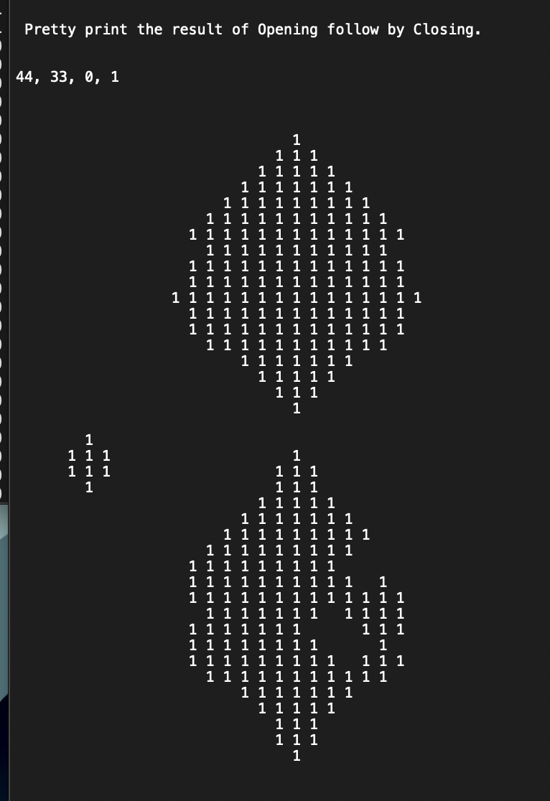

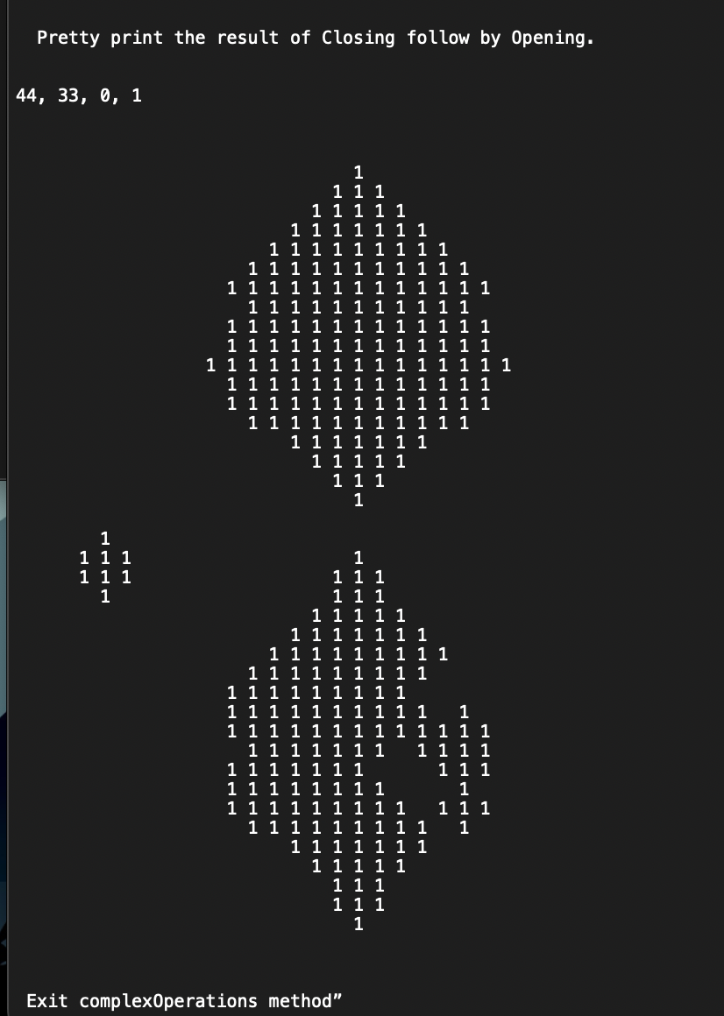

Data2 and elm2

Output1.txt

Output2.txt

Data3 and elm3

Output1.txt

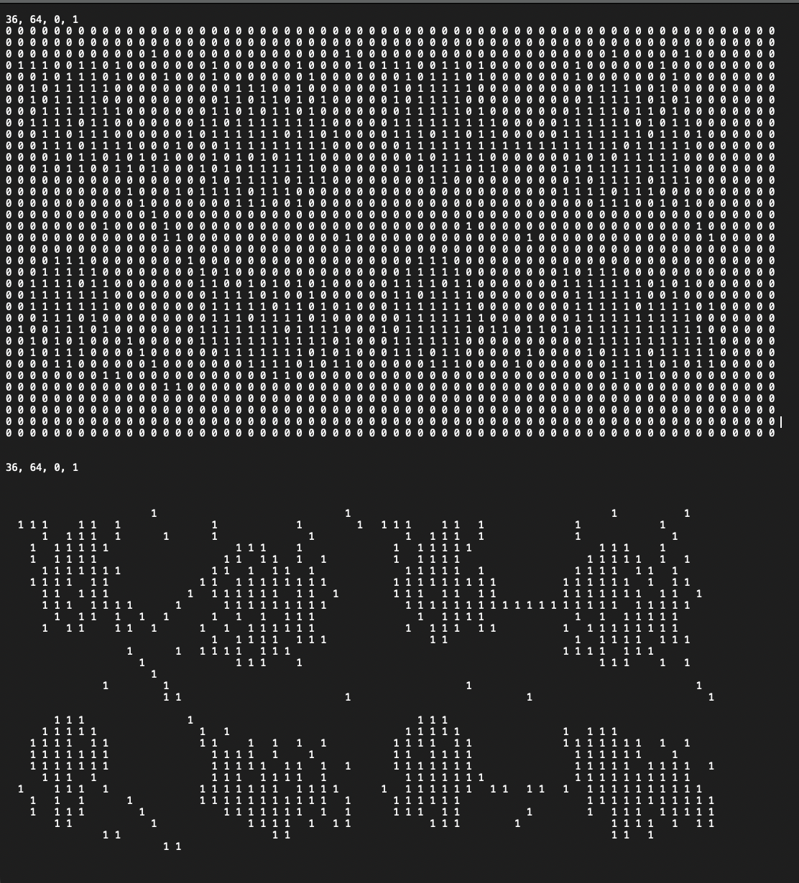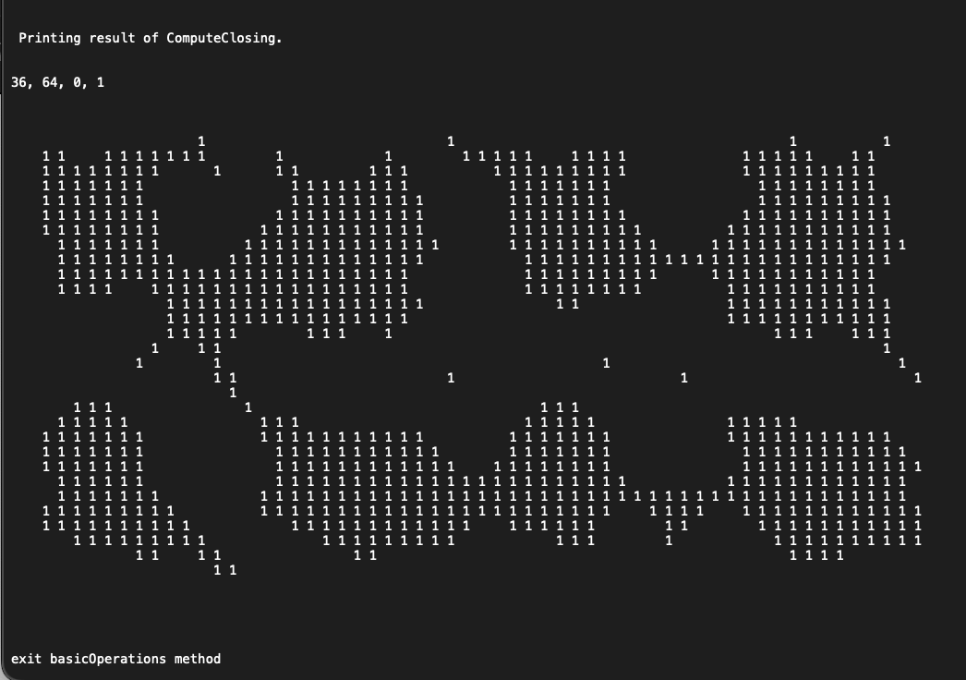

Output2.txt

**Source code**

Main.java

*import* java.io.*;  
  
*public class* Main {  
  
 *public static void* main(String[] args) *throws* IOException {  
 File img = *new* File(args[0]);  
 File elm = *new* File(args[1]);  
 File output1 = *new* File(args[2]);  
 File output2 = *new* File(args[3]);  
x  
 FileReader imgFile = *new* FileReader(img);  
 FileReader elmFile = *new* FileReader(elm);  
  
 FileWriter out1 = *new* FileWriter(output1);  
 FileWriter out2 = *new* FileWriter(output2);  
  
 *//step1* BufferedReader br = *new* BufferedReader(imgFile);  
 String line = br.readLine();  
 String[] values = line.split(" ");  
 *int* numImgRows = Integer.parseInt(values[0]),  
 numImgCols = Integer.parseInt(values[1]),  
 imgMin = Integer.parseInt(values[2]),  
 imgMax = Integer.parseInt(values[3]);  
  
 br = *new* BufferedReader(elmFile);  
 line = br.readLine();  
 values = line.split(" ");  
 *int* numStructRows = Integer.parseInt(values[0]),  
 numStructCols = Integer.parseInt(values[1]),  
 structMin = Integer.parseInt(values[2]),  
 structMax = Integer.parseInt(values[3]);  
  
 line = br.readLine();  
 values = line.split(" ");  
 *int* rowOrigin = Integer.parseInt(values[0]),  
 colOrigin = Integer.parseInt(values[1]);  
  
  
*// for (String s: values)  
// System.out.println(s);  
// System.out.println();  
  
 //step 2* Morphology proj = *new* Morphology(numImgRows, numImgCols, imgMin, imgMax, numStructRows, numStructCols, structMin, structMax, rowOrigin, colOrigin);  
  
 *//step 3  
// done in constructor  
  
 //step 4* imgFile.close();  
 imgFile = *new* FileReader(img);  
 proj.loadImg(imgFile);  
 *//step 5* proj.imgReformat(out1);  
 proj.prettyPrint(proj.zeroFramedAry, out1);  
  
 *//step 6* elmFile.close();  
 elmFile = *new* FileReader(elm);  
 proj.loadStruct(elmFile);  
 proj.prettyPrint(proj.structAry, out1);  
  
 *//step 7* proj.basicOP(out1);  
 out1.close();  
  
 *//step8* proj.complexOP(out2);  
  
 *//step 9* imgFile.close();  
 elmFile.close();  
  
 out2.close();  
  
  
 }  
}

Morphology.java

*import* java.io.BufferedReader;  
*import* java.io.FileReader;  
*import* java.io.FileWriter;  
*import* java.io.IOException;  
  
*public class* Morphology {  
  
 *int* numImgRows;  
 *int* numImgCols;  
 *int* imgMin;  
 *int* imgMax;  
 *int* numStructRows;  
 *int* numStructCols;  
 *int* structMin;  
 *int* structMax;  
 *int* rowOrigin;  
 *int* colOrigin;  
 *int* rowFrameSize;  
 *int* colFrameSize;  
 *int* extraRows;  
 *int* extraCols;  
 *int* rowSize;  
 *int* colSize;  
 *public int*[][] zeroFramedAry;  
 *public int*[][] morphAry;  
 *public int*[][] tempAry;  
 *public int*[][] structAry;  
  
  
 *public* Morphology(*int* numImgRows, *int* numImgCols, *int* imgMin, *int* imgMax, *int* numStructRows, *int* numStructCols, *int* structMin, *int* structMax, *int* rowOrigin, *int* colOrigin){  
  
 *this*.numImgRows = numImgRows;  
 *this*.numImgCols = numImgCols;  
 *this*.imgMin = imgMin;  
 *this*.imgMax = imgMax;  
 *this*.numStructRows = numStructRows;  
 *this*.numStructCols = numStructCols;  
 *this*.structMin = structMin;  
 *this*.structMax = structMax;  
 *this*.rowOrigin = rowOrigin;  
 *this*.colOrigin = colOrigin;  
  
 *this*.rowFrameSize = numStructRows /2;  
 *this*.colFrameSize = numStructCols /2;  
  
 *this*.extraRows = rowFrameSize*2;  
 *this*.extraCols = colFrameSize*2;  
 *this*.rowSize = numImgRows + extraRows;  
 *this*.colSize = numImgCols + extraCols;  
*//  
// System.out.println("numimg rows:" + numImgRows);  
// System.out.println("numimg col:" + numImgCols);  
// System.out.println("extraRows rows:" + extraRows);  
// System.out.println("extraCols rows:" + extraCols);  
// System.out.println("rowSize rows:" + rowSize);  
// System.out.println("colSize rows:" + colSize);  
  
 this*.zeroFramedAry = *new int*[rowSize][colSize];  
 *this*.morphAry = *new int*[rowSize][colSize];  
 *this*.tempAry = *new int*[rowSize][colSize];  
 *this*.structAry = *new int*[numStructRows][numStructCols];  
  
 zero2DAry(zeroFramedAry);  
 zero2DAry(morphAry);  
 zero2DAry(tempAry);  
 zero2DAry(structAry);  
 }  
  
 *public void* zero2DAry (*int*[][] arr){  
  
 *int* r = arr.length, c = arr[0].length;  
 *for* (*int* i=0; i<r;i++){  
 *for* (*int* j=0; j<c;j++){  
 arr[i][j]=0;  
 }  
 }  
 }  
  
 *public void* onePixelDilation(*int* i, *int* j, *int*[][] inArr, *int*[][]outArr) {  
 *int* iOffset = i - rowOrigin;  
 *int* jOffset = j - colOrigin;  
  
  
 *int* rIndex = 0;  
  
 *while* (rIndex < numStructRows) {  
 *//step 2  
 int* cIndex = 0;  
 *//step 5  
 while* (cIndex < numStructCols) {  
 *//step 3  
 if* (structAry[rIndex][cIndex] > 0) {  
*// System.out.println(iOffset + rIndex);  
// System.out.println(jOffset + cIndex);* outArr[iOffset + rIndex][jOffset + cIndex] = 1;  
 }  
  
 *//step 4* cIndex++;  
 }  
 *//step 6* rIndex++;  
 }  
  
 }  
  
 *public void* onePixelErosion(*int* i, *int* j, *int*[][] inArr, *int*[][]outArr){  
 *int* iOffset = i - rowOrigin;  
 *int* jOffset = j - colOrigin;  
 *boolean* match = *true*;  
  
 *//step1  
 int* rIndex = 0;  
  
  
 *//step 7  
 while* ((match) && (rIndex < numStructRows)) {  
 *//step 2  
 int* cIndex = 0;  
 *//step 5  
 while* ( (match) && (cIndex < numStructCols )) {  
 *//step 3  
 if* (structAry[rIndex][cIndex] > 0 &&  
 (inArr[iOffset + rIndex][jOffset + cIndex] ) <= 0) {  
 match = *false*;  
 }  
  
 *//step 4* cIndex++;  
 }  
 *//step 6* rIndex++;  
 }  
  
 *//step 8  
 if*(match){  
 outArr[i][j] = 1;  
 }*else*{  
 outArr[i][j] = 0;  
 }  
  
 }  
  
 *public void* computeDilation (*int*[][] inArr, *int*[][]outArr){  
 *//step 1  
 int* i = rowFrameSize;  
  
 *//step 7  
 while* (i<rowSize) {  
  
 *//step 2  
 int* j = colFrameSize;  
  
 *//step 5  
 while* (j < colSize) {  
  
 *//step 3  
 if* (inArr[i][j] > 0) {  
 onePixelDilation(i, j, inArr, outArr);  
 }  
  
 *//step 4* j++;  
 }  
  
 *//step 6;* i++;  
 }  
 }  
  
 *public void* computeErosion (*int*[][] inArr, *int*[][]outArr){  
 *//step1  
 int* i = rowFrameSize;  
  
 *//step 7  
 while* (i<rowSize) {  
 *//step2  
 int* j = colFrameSize;  
  
 *//step5  
  
 while* (j < colSize) {  
 *//step 3  
 if* (inArr[i][j] > 0) {  
 onePixelErosion(i, j, inArr, outArr);  
 }  
  
 *//step 4* j++;  
 }  
  
 *//step6* i++;  
 }  
 }  
  
 *public void* computeClosing(){  
 computeDilation(zeroFramedAry,tempAry);  
 computeErosion(tempAry, morphAry);  
 zero2DAry(tempAry);  
 }  
  
 *public void* computeOpening(){  
 computeErosion(zeroFramedAry, tempAry);  
 computeDilation(tempAry,morphAry);  
 zero2DAry(tempAry);  
 }  
  
 *public void* loadImg(FileReader input) *throws* IOException {  
 BufferedReader br = *new* BufferedReader(input);  
 String line = br.readLine();  
 *int* i=1;  
 *while*((line=br.readLine())!=*null*){  
 String[] c = line.split(" ");  
 *for*(*int* j=1; j<c.length; j++){  
 zeroFramedAry[i][j] = Integer.parseInt(c[j-1]);  
 }  
 i++;  
 }  
 }  
  
 *public void* loadStruct(FileReader input) *throws* IOException {  
 BufferedReader br = *new* BufferedReader(input);  
 String line = br.readLine();  
 line = br.readLine();  
 *int* i=0;  
 *while*((line=br.readLine())!=*null*){  
 String[] c = line.split(" ");  
 *for*(*int* j=0; j<c.length; j++){  
 structAry[i][j] = Integer.parseInt(c[j]);  
*// System.out.print(c[j]);* }  
*// System.out.println();* i++;  
 }  
 }  
  
 *public void* imgReformat(FileWriter output) *throws* IOException {  
 output.write("\n" + zeroFramedAry.length + ", " + zeroFramedAry[0].length + ", 0, 1\n");  
  
 *int* width = 1;  
  
 *int* r = 0;  
  
 *while* (r<zeroFramedAry.length){  
 *int* c = 0;  
 *while* (c<zeroFramedAry[0].length){  
  
 output.write(zeroFramedAry[r][c] + " ");  
 c++;  
 }  
 output.write("\n");  
 r++;  
 }  
  
 }  
  
 *public void* prettyPrint(*int*[][] arr, FileWriter output) *throws* IOException {  
  
 output.write("\n\n" + zeroFramedAry.length + ", " + zeroFramedAry[0].length + ", 0, 1\n\n");  
 *for* (*int* i = 0; i < arr.length; i++)  
 {  
 *for* (*int* j = 0; j < arr[0].length; j++)  
 {  
 *if*(arr[i][j]>0){  
 output.write(arr[i][j] + " ");  
 }*else*{  
 output.write( " ");  
 }  
 }  
 output.write("\n");  
  
 }  
 }  
  
 *public void* basicOP(FileWriter output)*throws* IOException{  
  
 *//step 0* output.write("\nentering basicOperations method \n");  
 *//step 1* zero2DAry(morphAry);  
 computeDilation(zeroFramedAry, morphAry);  
 output.write("\n Printing result of ComputeDilation. \n");  
 prettyPrint(morphAry,output);  
 *//step 2* zero2DAry(morphAry);  
 computeErosion(zeroFramedAry, morphAry);  
 output.write("\n Printing result of ComputeErosion. \n");  
 prettyPrint(morphAry,output);  
 *//step 3* zero2DAry(morphAry);  
 computeOpening();  
 output.write("\n Printing result of ComputeOpening. \n");  
 prettyPrint(morphAry,output);  
 *//step 4* zero2DAry(morphAry);  
 computeClosing();  
 output.write("\n Printing result of ComputeClosing. \n");  
 prettyPrint(morphAry,output);  
  
 *//step 5* output.write("\nexit basicOperations method\n");  
 }  
  
 *public void* complexOP(FileWriter output)*throws* IOException{  
 *//step 0* output.write("entering complexOperations method \n");  
  
 *//step 1* zero2DAry(morphAry);  
 computeOpening();  
 output.write("\n Printing result of Opening. \n");  
 prettyPrint(morphAry,output);  
 copyArr();  
  
 *//step 2* zero2DAry(morphAry);  
 computeClosing();  
 output.write("\n Pretty print the result of Opening follow by Closing. \n");  
 prettyPrint(morphAry,output);  
 copyArr();  
  
 *//step 3* zero2DAry(morphAry);  
 computeClosing();  
 output.write("\n Pretty print the result of Closing. \n");  
 prettyPrint(morphAry,output);  
 copyArr();  
  
 *//step 4* zero2DAry(morphAry);  
 computeOpening();  
 output.write("\n Pretty print the result of Closing follow by Opening. \n");  
 prettyPrint(morphAry, output);  
  
  
 output.write("\n Exit complexOperations method” \n");  
 }  
  
 *void* copyArr(){  
 *for* (*int* i=0; i<zeroFramedAry.length;i++){  
 System.arraycopy(morphAry[i], 0, zeroFramedAry[i], 0, zeroFramedAry[0].length);  
 }  
 }  
  
}